1.To see the list of all the customers in the database

I have entered the command

‘Select * from customers’

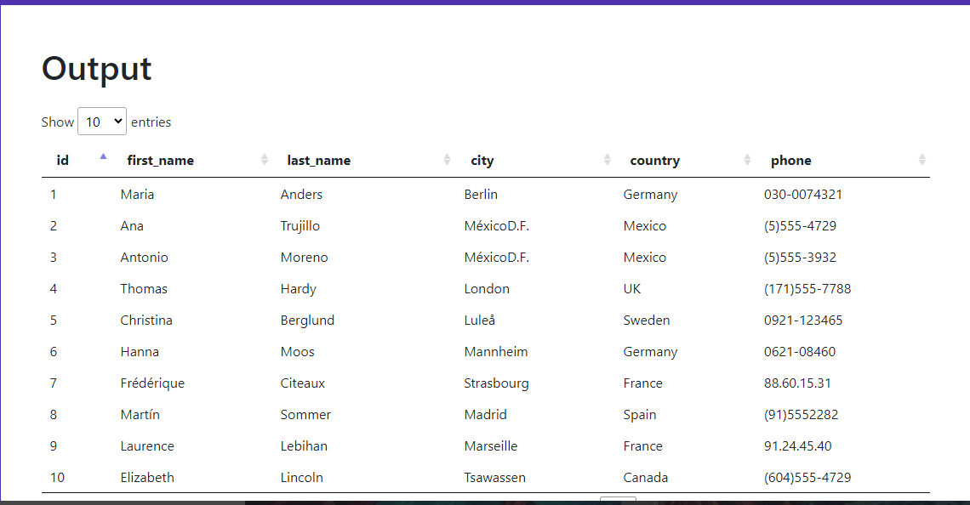

2. To see the list of all the product suppliers i have used the command

‘Select * from suppliers’

Below is the output 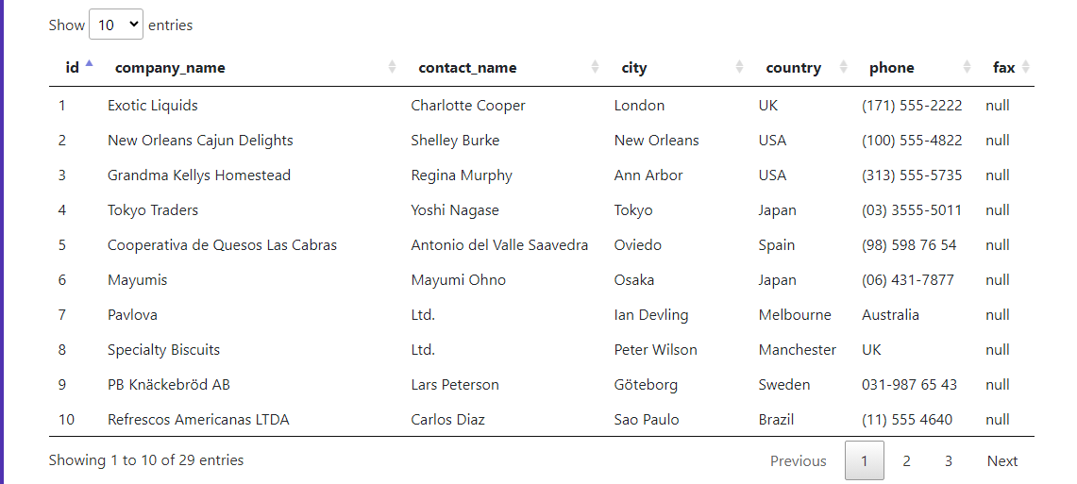

3. To see the name of all the products I have used the command

‘Select * from company_products’

Below is the output

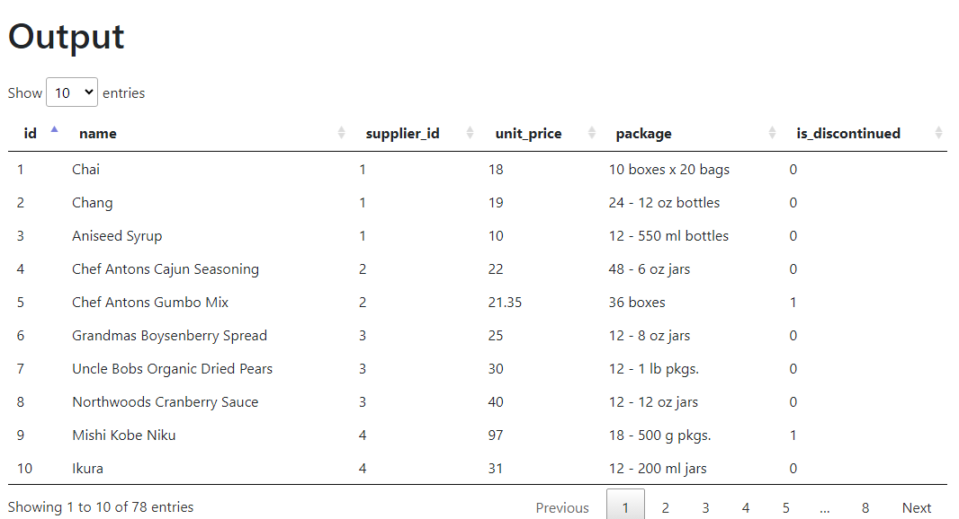

4. To see the name of the customers who are from mexico only

I have used the command

‘Select * from customers where country=’Mexico’ ’

Below is the output